1. returns true if the paddle and the ball are intersecting and returns false if they are not
2. using ternary operator to check which paddle we are dealing with, basically what way the ball is heading toward.
3. If they do intersect run the code in the brackets, what's going on in the curly brackets is once the ball hits the paddle the velocity is changed to send it back and also I am checking to see where abouts on the paddle the ball hits to make the game more realistic.

I could have just placed code such as "this.vel.x *= -1;" in but all that will do is projectile the ball directly back at the opposite paddle, I don’t want this because it will just be a straight line that the ball can move in; there is no variation of possible direction.

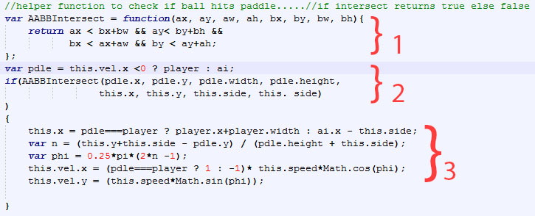

I added the following code to the AI, this allowed the AI to move and follow the ball, and impossible to win



I changed so it would actually be possible to beat the game!



______

The game is very bland, to make it more interesting and more like tennis I implemented a smash system, it's very simple each time the paddle hits the ball it now smashes it

